**SUSTAINABLE FERTILIZER USAGE OPTIMIZER FOR HIGHER YIELD**

**A PROJECT REPORT**

***Submitted by,***

**Ms. ANJANA M J - 20221LCE0010**

**Ms. KRUTHIKA K Y - 20221LCE0005**

**Ms. SUSHMITHA R - 20221LCE0004**

***Under the guidance of,***

**Dr. JOE ARUN RAJA**

***in partial fulfilment for the award of the degree of***

**BACHELOR OF TECHNOLOGY**

**IN**

**COMPUTER ENGINEERING**

**At**

**PRESIDENCY UNIVERSITY BENGALURU**

**MAY 2025**

**PRESIDENCY UNIVERSITY**

**SCHOOL OF COMPUTER SCIENCE ENGINEERING**

**CERTIFICATE**

This is to certify that the Project report **“Sustainable Fertilizer Usage Optimizer for Higher Yield”** being submitted by “SUSHMITHA R, KRUTHIKA K Y, ANJANA M J” bearing roll number(s) “20221LCE0004, 20221LCE0005, 20221LCE0010” in partial fulfillment of the requirement for the award of the degree of Bachelor of Technology in Computer Engineering is a bonafide work carried out under my supervision.

|  |  |
| --- | --- |
| **Dr. JOE ARUN RAJA,**  ASSOCIATE PROFESSOR  School of CSE Presidency University | **Dr. GOPAL KRISHNA SHYAM**  HOD of COM & CEI  School of CSE  Presidency University |

|  |  |  |
| --- | --- | --- |
| **Dr. MYDHILI NAIR**  Associate Dean  School of CSE Presidency University |  | **Dr. SAMEERUDDIN KHAN**  Pro-Vc School of Engineering  Dean -School of CSE&IS Presidency University |

**PRESIDENCY UNIVERSITY**

**SCHOOL OF COMPUTER SCIENCE ENGINEERING**

**DECLARATION**

We hereby declare that the work, which is being presented in the project report entitled **Sustainable Fertilizer Usage Optimizer for Higher Yield** in partial fulfilment for the award of Degree of **Bachelor of Technology** in **Computer Engineering**, is a record of our own investigations carried under the guidance of **DR. JOE ARUN RAJA, ASSOCIATE PROFESSOR,** **Presidency** **School of Computer Science Engineering, Presidency University, Bengaluru.**

We have not submitted the matter presented in this report anywhere for the award of any other Degree.

|  |  |  |
| --- | --- | --- |
| NAME | ROLL NUMBER | SIGNATURE |
| ANJANA M J | 20221LCE0010 |  |
| KRUTHIKA K Y | 20221LCE0005 |  |
| SUSHMITHA R | 20221LCE0004 |  |

# ABSTRACT

Fertilizer mismanagement is a significant challenge in modern agriculture, leading to soildegradation, decreased productivity, and environmental pollution. This project proposes a Sustainable Fertilizer Usage Optimizer—a data-driven application that analyzes soil health, crop type, and weather patterns to provide optimal fertilizer recommendations. By integrating AI,and predictive analytics, this system ensures precision farming, enhances crop yield, and supports sustainable agricultural practices. The platform is designed to be accessible to farmers, leveraging mobile applications, web-based dashboards, and localized language support. The expected impact includes improved soil fertility, optimized fertilizer costs, increased agricultural productivity, and reduced environmental damage.

This project presents a software-based solution that optimizes fertilizer usage for sustainable agriculture. The system analyzes soil data, crop type, and weather conditions to generate personalized fertilizer recommendations for farmers. By leveraging machine learning algorithms and real-time data analytics, the solution ensures optimal nutrient supply, reducing overuse and preventing soil degradation. The system's core functionalities include soil health analysis, dynamic fertilizer recommendations, and an interactive dashboard for farmers. Expected benefits include higher crop yields, cost-effective fertilizer application, and long-term soil health sustainability. The implementation of this system supports modern precision agriculture, helping farmers make data-driven decisions while promoting environmentally responsible farming practices.

# 

# ACKNOWLEDGEMENT

First of all, we indebted to the **GOD ALMIGHTY** for giving me an opportunity to excel in our efforts to complete this project on time.

We express our sincere thanks to our respected dean **Dr. Md. SAMEERUDDIN KHAN**, Pro-VC, School of Engineering and Dean, School of Computer Science Engineering & Information Science, Presidency University for getting us permission to undergo the project.

We express our heartfelt gratitude to our beloved Associate Deans **Dr. MYDHILI NAIR,** Presidency School of Computer Science Engineering & Information Science, Presidency University, and **Dr. GOPAL KRISHNA SHYAM**, Head of the Department, School of Computer Engineering, Presidency University, for rendering timely help in completing this project successfully. We are greatly indebted to our guide **DR. JOE ARUN RAJA, ASSOCIATE PROFESSOR** and Reviewer **Dr. P SUDHA** School of Computer Science Engineering, Presidency University for his/her inspirational guidance, and valuable suggestions and for providing us a chance to express our technical capabilities in every respect for the completion of the project work.

We would like to convey our gratitude and heartfelt thanks to the PIP2001 Capstone Project Coordinators **Dr. SAMPATH A K, Mr. Md ZIA UR RAHMAN,** department Project Coordinators and Git hub coordinator **Mr. MUTHURAJU V** We thank our family and friends for the strong support and inspiration they have provided us in bringing out this project.

**Anjana M J**

**Kruthika K Y**

**Sushmitha R**

**LIST OF TABLES**

|  |  |  |  |
| --- | --- | --- | --- |
| **Sl no.** | **Table**  **Name** | **Table Caption** | **Page No.** |
| 1 | Table 2.1 | Literature Survey | 7 |
| 2 | Table 3.8 | Summary of Research Gaps | 14 |
| 3 | Table 4.8 | Technology Stack | 21 |

**LIST OF FIGURES**

|  |  |  |  |
| --- | --- | --- | --- |
| **Sl no.** | **Figure no.** | **Title** | **Page no.** |
| 1 | Figure 4.1 | System Work Flow | 17 |
|  | Figure 4.2 | Data Flow Diagram(Level 0) | 18 |
|  | Figure 4.3 | Data Flow Diagram (Level 1) | 19 |
|  | Figure 4.4 | Flowchart of SFUO Fertilizer Optimization | 20 |
| 2 | Figure 6.1 | Front end Work Flow | 26 |
|  | Figure 6.2 | Backend Work Flow | 27 |
|  | Figure 6.3 | Fronted design of Input page | 28 |
|  | Figure 6.4 | Frontend design of output page | 29 |
| 3 | Figure 9.1 | Input Page | 34 |
|  | Figure 9.2 | Output Page | 35 |

**TABLE OF CONTENTS**

ABSTRACT 4

ACKNOWLEDGEMENT 5

CHAPTER 1 1

INTRODUCTION 1

1.1 Background of the Study 1

1.2 Problem Statement 2

1.3 Significance of the Study 2

1.4 Technological Landscape and Innovation 3

1.5 Research Scope and Framework 4

1.6 Research Questions 4

1.7 Conclusion 5

CHAPTER-2 6

LITERATURE SURVEY 6

2.1 Overview of Existing Technologies 6

2.2 Comparative Literature Summary 7

2.3 Observations and Insights from Literature 9

2.4 Relevance to the Proposed Work 10

2.5 Conclusion 10

CHAPTER-3 11

RESEARCH GAPS OF EXISTING METHODS 11

3.1 Introduction 11

3.2 Technological Gaps 11

3.2.1 Lack of Integration 11

3.2.2 Insufficient AI Adoption 11

3.3 Environmental Gaps 12

3.3.1 Lack of Eco-Friendly Fertilization Approaches 12

3.3.2 Ignoring Soil Health Dynamics 12

3.3.3 No Feedback Loops for Correction 12

3.4 Economic and Scalability Gaps 12

3.4.1 High Cost of Implementation 12

3.4.2 Poor Scalability 12

3.4.3 No Return on Investment (ROI) Analysis 12

3.5 Data and Infrastructure Gaps 13

3.5.1 Lack of Reliable Datasets 13

3.5.2 Connectivity and Infrastructure Limitations 13

3.5.3 Language and Interface Barriers 13

3.6 Usability and Human-Centric Gaps 13

3.6.1 Lack of Farmer Participation in Design 13

3.6.2 Absence of Training and Extension Support 13

3.6.3 Poor User Experience 13

3.7 Policy and Standardization Gaps 14

3.7.1 No Standardization of Fertilizer Guidelines 14

3.7.2 Lack of Incentivization 14

3.7.3 Poor Integration with Agricultural Policies 14

3.8 Summary of Research Gaps 14

3.9 Conclusion 15

CHAPTER 4 16

PROPOSED METHODOLOGY 16

4.1 Introduction 16

4.2 System Overview 16

4.1 System Work Flow 17

4.4 Data Flow Diagram (Level 0) 18

4.5 Data Flow Diagram (Level 1) 19

4.6 Flowchart of SFUO Fertilizer Optimization 20

4.7 Methodological Workflow 20

4.8 Technology Stack 21

4.9 Advantages of SFUO 21

4.10 Implementation Use Case Example 21

4.11 Limitations and Future Enhancements 21

4.12 Conclusion 22

CHAPTER-5 23

OBJECTIVES 23

CHAPTER-6 26

SYSTEM DESIGN & IMPLEMENTATION 26

6.1 Frontend Work Flow 26

6.2 Backend Data Flow 27

CHAPTER-7 30

TIMELINE FOR EXECUTION OF PROJECT 30

CHAPTER-8 31

OUTCOMES 31

CHAPTER-9 34

RESULTS AND DISCUSSIONS 34

CHAPTER 10 37

CONCLUSION 37

REFERENCES 39

APPENDICES 41

APPENDIX -A PSUEDOCODE 41

APPENDIX - B SCREENSHOTS 42

APPENDIX - C ENCLOSURES 47

# CHAPTER 1

# INTRODUCTION

## 1.1 Background of the Study

Agriculture has always been the backbone of human civilization, providing food, fiber, and raw materials for survival and economic growth. As the global population continues to grow, so does the demand for agricultural produce. According to the United Nations, the world population is expected to reach nearly 10 billion by 2050, requiring a 60% increase in food production. To meet this escalating demand, farmers worldwide are increasingly relying on fertilizers to enhance crop yield and soil fertility.

Fertilizers, particularly nitrogen (N), phosphorus (P), and potassium (K), are essential nutrients that promote plant growth and development. While the use of chemical fertilizers has undoubtedly played a significant role in boosting agricultural productivity, excessive and improper usage has resulted in several adverse consequences. These include soil degradation, nutrient runoff, water pollution, greenhouse gas emissions, and increased input costs for farmers.

In many developing countries, including India, fertilizer use is often not based on scientific analysis or soil needs but on conventional practices and government subsidies. This leads to overuse in some regions and underuse in others, disrupting the ecological balance. Furthermore, climate change adds another layer of complexity, as erratic rainfall patterns, increasing temperatures, and extreme weather events affect soil health and fertilizer absorption.

Hence, there is a pressing need for an intelligent, data-driven system that can optimize fertilizer use based on real-time soil conditions, crop requirements, and environmental factors. The proposed system—**Sustainable Fertilizer Usage Optimizer (SFUO)**—aims to address this challenge by integrating modern technologies such as Artificial Intelligence (AI), and precision agriculture techniques.

## 1.2 Problem Statement

The traditional approaches to fertilizer application lack precision and adaptability. In many agricultural regions, farmers apply fertilizers based on trial-and-error methods, often without considering soil nutrient levels or actual crop needs. This results in several critical problems:

* **Nutrient Imbalance:** Over-fertilization leads to toxic buildup of certain nutrients, while others may remain deficient, affecting crop quality and soil health.
* **Environmental Degradation:** Excess fertilizer often leaches into groundwater or runs off into water bodies, leading to eutrophication and contamination.
* **Economic Loss:** Fertilizers represent a significant portion of farm input costs. Improper usage leads to waste and reduced profitability for farmers.
* **Soil Degradation:** Long-term improper application can reduce soil microbial activity, alter pH levels, and result in diminished fertility.
* **Lack of Customization:** Conventional systems do not account for crop-specific, location-specific, or climate-specific factors when determining fertilizer needs.

The Sustainable Fertilizer Usage Optimizer seeks to bridge these gaps by offering tailored recommendations based on real-time field data and predictive analytics. This system promotes a scientific approach to nutrient management that supports both high productivity and environmental stewardship.

## 1.3 Significance of the Study

This study holds tremendous significance at both the micro (farm-level) and macro (global) levels. By enhancing fertilizer efficiency, the SFUO system contributes to the following areas:

**a) Agricultural Productivity**

The core benefit of SFUO is the increased efficiency in fertilizer usage, leading to improved crop health, higher yields, and better quality of produce. With precise nutrient delivery, plants receive what they need, when they need it.

**b) Cost-Effectiveness**

With fertilizer prices rising and representing a large share of input costs, SFUO helps farmers reduce unnecessary expenditures by applying only the required amount based on scientific analysis.

**c) Environmental Sustainability**

Minimizing over-application reduces harmful runoff into rivers and lakes, lessens greenhouse gas emissions (especially from nitrogen-based fertilizers), and preserves soil biodiversity. This aligns with global sustainability goals such as those outlined by the UN Sustainable Development Goals (SDGs).

**d) Data-Driven Agriculture**

The project promotes a shift toward smart farming, where decisions are based on real-time data, analytics, and AI models. This represents a leap toward modern, resilient, and climate-smart agriculture.

**e) Policy and Extension Support**

The insights from SFUO can inform policymakers about regional nutrient usage trends and help agricultural extension workers offer more accurate guidance to farmers.

## 1.4 Technological Landscape and Innovation

In recent years, technological advances have revolutionized agriculture. Smart sensors, drones, GPS-guided equipment, and machine learning models are now being used for crop monitoring, irrigation management, pest control, and yield prediction. However, fertilizer application has not fully benefited from these innovations, particularly in small and medium-sized farms.

SFUO aims to fill this technological void. The system combines:

* **AI Algorithms:** Machine learning and deep learning models predict fertilizer requirements based on diverse input data.
* **Precision Agriculture Techniques:** Tools ensure accurate delivery of fertilizers at different field zones.
* **Web Platforms:** A user-friendly interface allows farmers to access recommendations, alerts, and reports in real time.

This holistic integration ensures that fertilizer use is tailored to specific field conditions, making agriculture more efficient and sustainable.

## 1.5 Research Scope and Framework

The scope of this study includes the design, development, and implementation of an intelligent fertilizer optimization system that can be scaled across different crops and geographical regions. The research covers the following key areas:

* Collection and analysis of soil, weather, and crop data
* Development of machine learning models for fertilizer recommendation
* Design of precision application strategies

The system is expected to be modular and adaptable, allowing it to be expanded or modified based on local requirements. The research also includes a detailed assessment of existing approaches and a comparison of their effectiveness with the proposed method.

## 1.6 Research Questions

This study is guided by several critical questions:

1. How can real-time data improve the efficiency of fertilizer usage?
2. What machine learning models are most effective in predicting optimal fertilizer application?
3. How does precision application influence yield and environmental outcomes?
4. What challenges exist in implementing such a system at scale in developing countries?
5. Can the SFUO model be generalized to work across diverse climatic zones and crop types?

## 1.7 Conclusion

The introduction of smart, sustainable systems like the **Sustainable Fertilizer Usage Optimizer (SFUO)** represents a pivotal step in transforming traditional agricultural practices. In a time of mounting pressure on food systems, climate uncertainties, and dwindling natural resources, data-driven solutions are no longer optional—they are essential.

This chapter has outlined the rationale, significance, and direction of the study. The subsequent chapters will delve deeper into the existing literature, identify research gaps, and present the methodology for developing and implementing the SFUO system. By integrating modern technology with time-tested agricultural practices, this research aspires to contribute meaningfully to the future of sustainable agriculture.

# CHAPTER-2

# LITERATURE SURVEY

Agriculture has always been one of the fundamental pillars of economic development and human sustenance. With the growing population and climate challenges, the need for smart, sustainable, and efficient agricultural practices has become more critical than ever. Among all the inputs required in agriculture, fertilizers play a vital role in enhancing productivity. However, improper use of fertilizers can degrade soil health, pollute water bodies, and lead to diminishing returns over time. Hence, the need for intelligent systems that ensure optimized fertilizer usage while maintaining environmental sustainability is paramount.

This chapter reviews existing literature on sustainable fertilizer management, AI-based decision systems in agriculture, precision agriculture. The goal is to identify current trends, breakthroughs, and limitations to inform the development of the Sustainable Fertilizer Usage Optimizer (SFUO) proposed in this study.

## 2.1 Overview of Existing Technologies

Technological advancements in the agriculture sector have led to the emergence of tools like remote sensing, machine learning, cloud computing, and automated machinery, collectively known as smart farming or precision agriculture. Several studies have explored different aspects of fertilizer optimization using these technologies. However, most existing systems are isolated, focusing either on data collection or analysis, but rarely providing an integrated, end-to-end solution.

Many existing methods rely on static data, manual assessment, and generalized dosage recommendations, which may not be suitable for different crop types or soil conditions. Others utilize sensors and remote sensing for monitoring purposes but lack the intelligence to suggest actionable, adaptive fertilizer strategies.

## 2.2 Comparative Literature Summary

**Table 2.1: Summary of Existing Work**

|  |  |  |  |  |
| --- | --- | --- | --- | --- |
| Sl.No | TITLE | AUTHOR(s) | YEAR | REMARK |
| 1 | Based Smart Fertilizer Recommendation System | Sharma et al. | 2020 | Rule-based system using soil sensors; lacks real-time adaptation. |
| 2 | Precision Agriculture with AI Techniques | Wang & Li | 2019 | Introduced ML for soil analysis but only supports maize crops. |
| 3 | Fertilizer Optimization Using Wireless Sensor Networks | Kumar & Bose | 2021 | Demonstrated real-time monitoring; didn't link to application automation. |
| 4 | Sustainable Agriculture Using ICT Tools | Patel et al. | 2020 | Focused on information delivery, not smart recommendations. |
| 5 | Fertilizer Decision Support System Using Machine Learning | Rajan & Sinha | 2022 | ML predictions effective but lacked sensor integration. |
| 6 | Smart Farming: A Review | Verma et al. | 2021 | Survey of technologies without practical implementation insights. |
| 7 | Environmental Effects of Fertilizer Overuse | Zeng et al. | 2018 | Highlighted harmful runoff effects but lacked mitigation strategies. |
| 8 | Real-Time Soil Monitoring with | Jha & Bhandari | 2021 | Reliable soil sensors; didn’t include recommendation generation. |
| 19 | A Survey on Precision Agriculture | Joshi et al. | 2019 | Valuable summary, but too generalized for fertilizer-specific optimization. |
| 10 | AI-Powered Crop Management Systems | Park & Hwang | 2022 | Applied DL for plant health, not directly on fertilizer usage. |
| 11 | Role of Big Data in Smart Farming | Chatterjee & Singh | 2020 | Focused on macro trends; lacked field-level decision tools. |
| 12 | Impact of Fertilizer Usage on Crop Yield | Gupta et al. | 2017 | Strong yield analysis; no optimization logic offered. |
| 13 | Soil Health Monitoring in Sustainable Agriculture | Rahman et al. | 2021 | Emphasized sustainability; lacked tech-backed solutions. |
| 14 | Deep Learning Models in Smart Agriculture | Lee et al. | 2021 | Focus on leaf imagery; not suitable for underground soil analysis. |
| 15 | Decision Trees for Fertilizer Dosage Prediction | Srivastava et al. | 2020 | Used single-year data; didn't adjust over seasons. |
| 16 | Sensor-Driven Precision Agriculture | Nair & Thomas | 2021 | Real-time feedback lacking decision-making automation. |
| 17 | Climate-Smart Agriculture: A Review | Fatima et al. | 2018 | Conceptual discussion; lacked technical depth. |
| 18 | Crop-Specific Fertilizer Algorithms | Rao & Pillai | 2022 | Effective but limited to rice and wheat under uniform climate. |

## 2.3 Observations and Insights from Literature

From the literature above, we can identify the following commonalities and gaps:

* **Strengths Identified**:
  + Reliable soil sensors can detect pH, moisture, and NPK levels.
  + AI and ML show promise in yield prediction and risk assessment.
* **Key Limitations**:
  + Most models are limited to static datasets without learning over time.
  + Scalability and adaptability across crops, climates, and soil types are weak.
  + Systems lack automated feedback loops for continuous optimization.
  + Integration of data collection, AI analysis, and automated application is rare.
  + User interfaces are often non-intuitive, especially for small-scale farmers.

## 2.4 Relevance to the Proposed Work

The Sustainable Fertilizer Usage Optimizer (SFUO) distinguishes itself from the above works in several key ways:

1. **Adaptive Learning**: Uses machine learning models that improve with every season and sensor update.
2. **Farmer-Centric Design**: Includes a user-friendly interface with multilingual support and local recommendations.
3. **Environmental Focus**: Prioritizes reduced leaching and optimized usage to promote sustainability.

## 2.5 Conclusion

The existing literature offers valuable insights into fertilizer management and precision agriculture. However, a comprehensive system that is adaptive, automated, environmentally conscious, and accessible to all categories of farmers is still lacking. The proposed SFUO methodology seeks to fill this critical gap. It is designed to revolutionize the way fertilizers are used by making them smarter, sustainable, and aligned with modern technological capabilities.

# 

# CHAPTER-3

# RESEARCH GAPS OF EXISTING METHODS

## 3.1 Introduction

The development of sustainable and intelligent agricultural practices is one of the most significant global challenges of the 21st century. Although technological innovations such as precision agriculture, artificial intelligence (AI), and Internet of Things () have been introduced into farming systems, many existing fertilizer optimization methods remain fragmented, inefficient, or inaccessible to the broader farming community.

This chapter systematically explores the research gaps and limitations in current methodologies concerning fertilizer management. These gaps, categorized under technological, environmental, economic, and usability dimensions, highlight the need for a holistic, scalable, and adaptive solution—such as the proposed Sustainable Fertilizer Usage Optimizer (SFUO).

## 3.2 Technological Gaps

### 3.2.1 Lack of Integration

Most existing systems focus on isolated functionalities—either sensor-based monitoring, data collection, or machine learning predictions. However, very few provide a fully integrated solution that combines all these elements in a real-time, responsive platform. Without integration, the cycle of sensing, analyzing, deciding, and applying remains disjointed, leading to inefficiencies and delays in execution.

.

### 3.2.2 Insufficient AI Adoption

Although AI is increasingly used in crop yield prediction and pest detection, few systems apply AI to dynamic fertilizer optimization. Moreover, existing AI models often lack the capability to learn over time (continuous learning) or adapt to multi-seasonal crop patterns, making them unsuitable for long-term, evolving agricultural needs.

## 3.3 Environmental Gaps

### 3.3.1 Lack of Eco-Friendly Fertilization Approaches

Many existing systems optimize yield without considering the long-term environmental impact of excessive fertilizer usage. Over-application leads to nutrient runoff, soil degradation, and water body pollution. There's a notable absence of strategies that balance yield with ecological responsibility.

### 3.3.2 Ignoring Soil Health Dynamics

Soil health is dynamic, influenced by multiple parameters like crop rotation, irrigation, and organic matter. Current methods do not holistically account for these changes. Most decision-making systems focus only on pH or NPK levels, ignoring comprehensive soil biology and texture variations, which are crucial for sustainable fertilization.

### 3.3.3 No Feedback Loops for Correction

Environmental conditions can change rapidly, requiring a feedback system that can recalibrate fertilizer recommendations based on crop performance and soil nutrient depletion. Existing systems lack this adaptability.

## 3.4 Economic and Scalability Gaps

### 3.4.1 High Cost of Implementation

Many smart agriculture solutions are financially inaccessible to small and marginal farmers, especially in developing countries. Complex software, and high maintenance costs create a digital divide.

### 3.4.2 Poor Scalability

Several models and applications are developed for specific regions or crop types, and cannot be easily scaled or generalized.

### 3.4.3 No Return on Investment (ROI) Analysis

Most systems don't include a **cost-benefit analysis module** that demonstrates ROI for fertilizer usage. Farmers need to understand not just agronomic benefits, but also economic viability, to adopt such technologies with confidence.

## 3.5 Data and Infrastructure Gaps

### 3.5.1 Lack of Reliable Datasets

A major limitation is the absence of large, labeled, and validated datasets that represent diverse soil types, crop varieties, and climate zones. This severely restricts the training and validation of AI models for fertilizer optimization.

### 3.5.2 Connectivity and Infrastructure Limitations

In many rural areas, poor internet connectivity and unreliable power supply make it difficult to implement cloud-based or real-time decision systems. Existing tools often presume robust infrastructure, making them unsuitable for many real-world contexts.

### 3.5.3 Language and Interface Barriers

A significant proportion of agricultural tools are designed in English or have complex interfaces, making them inaccessible to non-tech-savvy farmers or those from non-English-speaking backgrounds.

## 3.6 Usability and Human-Centric Gaps

### 3.6.1 Lack of Farmer Participation in Design

Many systems are developed in isolation from the end-users—the farmers themselves. Without farmer-centric design thinking, these tools often fail in practical deployment due to complexity or irrelevance to local farming practices.

### 3.6.2 Absence of Training and Extension Support

Even when tools are available, lack of awareness, education, and support inhibits their use. Research suggests that adoption of sustainable technology is directly tied to the level of guidance provided to the users.

### 3.6.3 Poor User Experience

Many tools fail to offer a smooth, intuitive user experience (UX), discouraging long-term usage. Web platforms often lack localization, voice support, or simple navigation, especially critical for elderly or less educated users.

## 3.7 Policy and Standardization Gaps

### 3.7.1 No Standardization of Fertilizer Guidelines

There is a lack of standardized national or international guidelines on smart fertilizer usage across different crop and soil types. This leads to inconsistencies in system recommendations and confuses users.

### 3.7.2 Lack of Incentivization

Governments and agencies have not yet developed enough incentive-based models for adopting smart fertilizer solutions. Without economic or policy-driven motivations, many farmers are hesitant to shift from traditional methods.

### 3.7.3 Poor Integration with Agricultural Policies

Existing smart systems are not always aligned with government subsidy, insurance, and sustainability policies. As a result, there's a disconnect between innovation and institutional support.

## 3.8 Summary of Research Gaps

The table below summarizes the key research gaps found in existing fertilizer management systems:

Table 3.8: Summary of Research Gaps

|  |  |
| --- | --- |
| **Category** | **Identified Gap** |
| Technological | Lack of integration, real-time intelligence, adaptive AI |
| Environmental | Overlooked sustainability, absence of dynamic soil health tracking |
| Economic/Scalability | High cost, lack of ROI clarity, region-specific design |
| Data/Infrastructure | Dataset scarcity, rural connectivity issues |
| Usability | Complex interfaces, low farmer involvement, poor UX |
| Policy | Lack of standards and alignment with subsidies |

## 3.9 Conclusion

Despite considerable progress in agricultural technology, numerous critical research gaps remain unaddressed in the context of sustainable fertilizer usage. These gaps hinder the practical effectiveness, scalability, and accessibility of existing solutions. The SFUO (Sustainable Fertilizer Usage Optimizer) proposed in this project is designed specifically to overcome these challenges by integrating data-driven decision-making, user-friendly interfaces, scalable architecture, and environmental consciousness into a single holistic system.

In the upcoming chapter, we will describe the proposed methodology, detailing how it fills these gaps and provides a comprehensive solution to modern agricultural fertilizer management.

# CHAPTER 4

# PROPOSED METHODOLOGY

## 4.1 Introduction

Modern agriculture faces the dual challenge of maximizing productivity while preserving the environment. Traditional fertilizer practices, often based on generalized schedules rather than actual field data, lead to problems such as soil nutrient depletion, pollution of water bodies through runoff, and declining agricultural efficiency. These concerns underline the urgent need for a data-driven, precision-focused approach to fertilizer management.

The proposed solution is the Sustainable Fertilizer Usage Optimizer (SFUO), which integrates advanced technologies like Artificial Intelligence (AI), machine learning (ML), and precision agriculture tools. The aim is to create a system capable of automated fertilizer application, and feedback-based optimization to increase yield, lower costs, and sustain the environment.

## 4.2 System Overview

The SFUO methodology is a closed-loop, intelligent decision-making system designed for modern farms. It connects sensors deployed in fields and machine learning models that guide precise fertilizer use.

This system operates through the following high-level process:

1. **Input Gathering** – Real-time soil and weather data from csv file , and manual inputs from farmers.
2. **Smart Analysis** – AI models analyze the data to generate optimal fertilizer plans.
3. **Monitoring & Feedback** – Post-application data is analyzed to update future recommendations.

## 4.1 System Work Flow

Fig 4.1 System Work Flow

**1. User Input (Soil Data, Crop Type, Weather)**

* The system starts with user-provided data such as:
  + **Soil Data**: pH, nutrients (N, P, K), moisture
  + **Crop Type**: the plant being cultivated
  + **Weather**: temperature, humidity, rainfall, etc.

**2. Web Interface (Flask, HTML, CSS, JavaScript)**

* A **user-friendly web interface** is built using:
  + **Flask**: Python web framework
  + **HTML/CSS/JS**: For designing the frontend
* This interface collects input data from the user.

**3. Backend API (Flask, Python, ML Model)**

* Flask handles HTTP requests and sends the user input to:
  + A **Python-based backend**
  + Which calls the **ML model** for predictions

**4. Machine Learning Model (Random Forest)**

* The core logic involves a **Random Forest classifier/regressor**:
  + It processes the input data
  + Predicts the **most suitable fertilizer** based on training

**5. Database (MySQL for Data Storage)**

* A **MySQL database** is used to:
  + Store input data
  + Keep logs of predictions
  + Possibly store fertilizer data

**6. Fertilizer Recommendation Output**

* Finally, the system returns:
  + **Recommended fertilizer type**
  + Based on soil, crop, and environmental data

## 4.4 Data Flow Diagram (Level 0)

* Farmer (Input source)
* SFUO System (Processing center)
* Actuation Devices (Output)

Farmer

SFUO Decision Hub

Fertilizer Plan

Fig 4.2 Data Flow Diagram (Level 0)

**Description:** The farmer inputs data (crop type, field location). The SFUO hub processes this with real-time sensor and satellite data, and outputs an optimized fertilizer plan.

## 4.5 Data Flow Diagram (Level 1)

**Modules:**

* Sensor Input
* Data Cleaning & Storage
* ML Analysis
* Recommendation Engine
* Application System
* Monitoring

Manual Input

Preprocessing

ML Analysis

Monitoring

Fertilizer Plan

Fig 4.3 Data Flow Diagram (Level 1)

Each module processes data and sends it downstream for further action or analysis.

## 4.6 Flowchart of SFUO Fertilizer Optimization

Start

|

Collect Soil Data --> Collect Weather Data --> Farmer Input

|

Clean Data & Normalize

|

Run AI Model (Crop + Soil + Weather)

|

Generate Fertilizer Plan (Type + Quantity + Time)

|

Monitor Crop Response

|

End

Fig 4.4 Flowchart of SFUO Fertilizer Optimization

## 4.7 Methodological Workflow

1. **Data Acquisition**:
   * Manual inputs.
   * Streaming of data
2. **Data Preprocessing**:
   * Filtering sensor noise.
   * Normalization and feature extraction.
3. **Model Selection & Training**:
   * Trained on historical data from various agro-climatic zones.
4. **Recommendation Generation**:
   * Fertilizer recommendations tailored to crop stage and weather.

## 4.8 Technology Stack

Table 4.8 Technology Stack

|  |  |
| --- | --- |
| **Layer** | **Tools/Technologies** |
| Backend | Python, Flask/Node.js |
| AI/ML Frameworks | TensorFlow, Scikit-learn |
| Database | MySQL, Firebase |
| Frontend | ReactJS, Bootstrap |

## 4.9 Advantages of SFUO

* **Reduced Input Costs**: By applying exact amounts of nutrients, waste is minimized.
* **Higher Yields**: Crops receive nutrition according to their growth phases.
* **Eco-Friendly**: Reduces eutrophication and groundwater pollution.
* **Scalability**: Can be deployed in small farms to large estates.
* **Farmer Empowerment**: Real-time dashboards and alerts for decision-making.

## 4.10 Implementation Use Case Example

**Farmer Ramesh** owns a 5-acre maize farm in Karnataka.

* **Soil Report**: Low nitrogen, high pH.
* **Weather Forecast**: Rainfall expected in 4 days.
* **System Suggestion**: Split application of nitrogen using urea in 3 phases.

**Implementation**:

* Phase 1: Pre-sowing – 40%
* Phase 2: 21 days post-germination – 30%
* Phase 3: Pre-flowering – 30%

Using drone sprayers, Ramesh applies fertilizers precisely, and yield increases by 20%.

## 4.11 Limitations and Future Enhancements

* **Initial Investment**: Sensors, drones, and connectivity may be expensive.
* **Connectivity Gaps**: Remote regions may lack consistent data networks.
* **Data Requirements**: AI models require diverse training data to avoid bias.

## 4.12 Conclusion

The proposed Sustainable Fertilizer Usage Optimizer (SFUO) presents a comprehensive and intelligent approach to modernizing fertilizer management in agriculture. By leveraging the combined power of sensors, machine learning algorithms, and precision agriculture tools, the methodology is designed to address the inefficiencies and environmental concerns associated with conventional fertilizer practices. The integration of real-time data acquisition with AI-driven decision-making ensures that nutrient application is optimized for both yield maximization and sustainability.

This methodology empowers farmers with personalized recommendations, reducing guesswork and enabling data-informed decisions. Through the use of Variable Rate Technology and smart monitoring systems, SFUO minimizes fertilizer wastage and protects soil health, ultimately contributing to long-term agricultural productivity. The inclusion of automated systems and cloud-based interfaces further improves accessibility and scalability for small and large farms alike.

Importantly, the proposed system supports adaptive learning, which allows it to evolve continuously based on user feedback and environmental variations. This ensures that recommendations remain accurate and context-specific, even as climate patterns shift or new crops are introduced. Additionally, the methodology promotes eco-friendly farming practices by reducing nutrient leaching and runoff, protecting nearby ecosystems and water sources.

The use case examples and technology stack demonstrate the real-world applicability of SFUO, reinforcing its practicality. While the system is robust and innovative, it also leaves room for future enhancements through integration with blockchain for traceability, advanced weather forecasting models, and larger datasets for AI training. In summary, the proposed methodology has the potential to revolutionize fertilizer usage across diverse agricultural landscapes, supporting both food security and environmental stewardship in the era of smart farming.

# CHAPTER-5

# OBJECTIVES

**5.1 Introduction**

Agricultural sustainability is a pressing global concern, especially as the world’s population continues to grow and climate conditions become increasingly unpredictable. The overuse and improper application of chemical fertilizers have led to adverse environmental impacts, including soil degradation, water pollution, and reduced biodiversity. Consequently, there is a vital need to develop systems that not only optimize crop yield but also ensure the responsible and efficient use of fertilizers. This chapter outlines the primary and secondary objectives of the **Sustainable Fertilizer Usage Optimizer (SFUO)** project, which is designed to address these critical agricultural challenges.

The SFUO aims to integrate artificial intelligence, and precision agriculture techniques to formulate an intelligent, responsive, and farmer-friendly solution that enhances fertilizer efficiency, improves crop productivity, and supports environmental conservation. These objectives align with global goals for sustainable agriculture and serve as a roadmap for the development, implementation, and evaluation of the proposed system.

**5.2 Primary Objectives**

The core objective of the SFUO is to optimize fertilizer usage through a data-driven and sustainable approach that ensures maximum crop productivity while preserving ecological balance. The primary goals are outlined as follows:

**Objective 1: Minimize Fertilizer Wastage**

* Develop a system that analyzes real-time soil and crop data to determine the exact quantity and type of fertilizers required.
* Reduce excessive application of nitrogen, phosphorus, and potassium, thereby preventing runoff and nutrient leaching.

**Objective 2: Enhance Crop Yield and Productivity**

* Utilize machine learning models to provide accurate, crop-specific fertilizer recommendations that enhance overall yield.
* Adjust application rates dynamically based on crop growth stages, weather conditions, and real-time field feedback.

**Objective 3: Improve Soil Health and Longevity**

* Promote balanced nutrient distribution to maintain optimal soil fertility and prevent long-term degradation.
* Monitor soil parameters regularly to assess health indicators and recommend corrective measures proactively.

**Objective 4: Reduce Environmental Impact**

* Decrease the ecological footprint of agriculture by minimizing greenhouse gas emissions and water contamination caused by chemical fertilizers.
* Encourage environmentally responsible farming practices through precision agriculture tools.

**Objective 5: Provide Real-Time Decision Support**

* Create a user-friendly platform that delivers instant alerts, visual analytics, and actionable insights based on field conditions.
* Enable farmers to make informed decisions using evidence-based recommendations.

**Objective 6: Ensure Scalability and Affordability**

* Design a modular and cost-effective system that can be implemented on small farms, large agricultural enterprises, and across different geographies.
* Use open-source tools and scalable cloud infrastructure to lower the barrier to adoption.

**5.4 Alignment with Sustainable Development Goals (SDGs)**

The SFUO initiative aligns with multiple United Nations Sustainable Development Goals, particularly:

* **SDG 2: Zero Hunger** – By improving crop productivity and soil health, the system directly supports global food security.
* **SDG 12: Responsible Consumption and Production** – Encourages sustainable use of resources by minimizing chemical input waste.
* **SDG 13: Climate Action** – Reduces the negative environmental impacts of agriculture and supports adaptation to climate variability.
* **SDG 15: Life on Land** – Protects terrestrial ecosystems by preventing soil erosion, nutrient depletion, and biodiversity loss.

**5.5 SMART Objective Framework**

To ensure clarity and direction, the objectives have been formulated using the SMART criteria:

| **Criteria** | **Application in SFUO** |
| --- | --- |
| **Specific** | Focused on fertilizer optimization, environmental protection, and yield improvement. |
| **Measurable** | Success can be quantified through metrics such as fertilizer reduction %, yield gain %, and soil health scores. |
| **Achievable** | Based on current technology trends (AI) and scalable implementations. |
| **Relevant** | Directly addresses key agricultural challenges and farmer needs. |
| **Time-bound** | System deployment and impact measurement expected within 1-2 growing seasons. |

**5.6 Conclusion**

The objectives outlined in this chapter form the foundation for developing the Sustainable Fertilizer Usage Optimizer. By focusing on both immediate agricultural challenges and long-term environmental sustainability, the SFUO project aspires to empower farmers with innovative tools to make smarter decisions. Its holistic framework addresses the technical, ecological, and economic aspects of farming, making it a practical and impactful solution for modern agriculture. These objectives will guide the design, implementation, and evaluation of the system in subsequent chapters, ensuring that the end result is both effective and future-ready.

# CHAPTER-6

# SYSTEM DESIGN & IMPLEMENTATION

## 6.1 Frontend Work Flow

User Opens Web Application

Input Form Displayed (Crop Type, Soil pH, Moisture, Temperature, Weather, etc.)

User Submits Input Data

Send Data to Backend via API

Wait for Fertilizer Prediction Response

Display Predicted Fertilizer on Webpage

User May Download / Save / Provide Feedback

End

Fig 6.1 Front end Work Flow

The frontend workflow of the SFUO (Sustainable Fertilizer Usage Optimizer) system begins when the user, typically a farmer, opens the web application through a browser. Upon access, an input form is displayed where the user is prompted to enter essential information such as crop type, soil pH, moisture levels, temperature, and current weather conditions. Once the data is entered, the user submits the form, triggering a secure API call that sends the input data to the backend server for processing.

## 6.2 Backend Data Flow

API Receives Input Data

from Frontend

Validate Input Data

Preprocess Data for ML Model

(Normalize, Format, Check for Nulls)

Load Trained ML Model

Run Prediction

Return Predicted Fertilizer to Frontend

Log Data and Prediction in Database

End

Fig 6.2 Backend Work Flow

The backend data flow of the SFUO system begins when the API receives the input data submitted by the user through the frontend interface. This data typically includes crop type, soil characteristics, and weather conditions. Once received, the system first validates the input to ensure completeness and correctness. After validation, the data undergoes preprocessing where it is normalized, formatted, and checked for any missing or null values to ensure compatibility with the machine learning model.

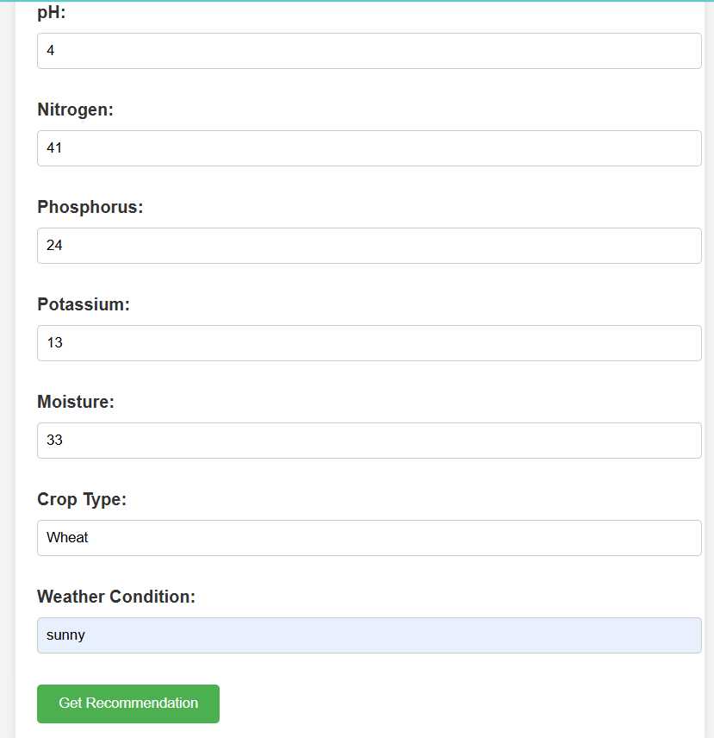

Fig 6.3 Fronted design of Input page

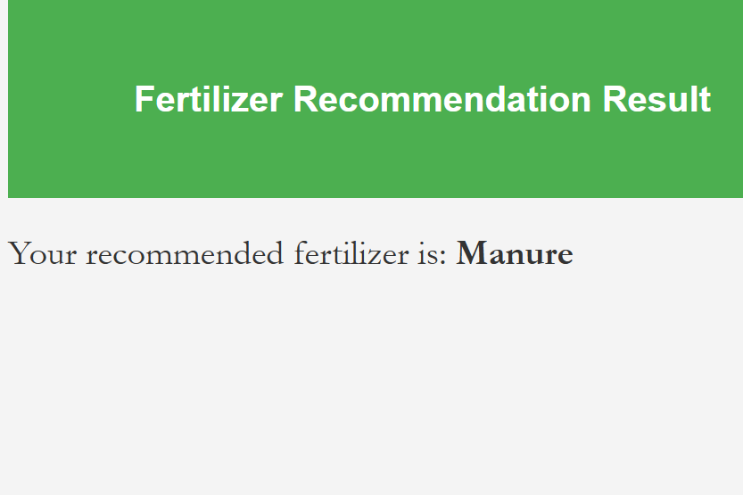

Fig 6.4 Frontend design of output page

# CHAPTER-7

# TIMELINE FOR EXECUTION OF PROJECT

**(GANTT CHART)**

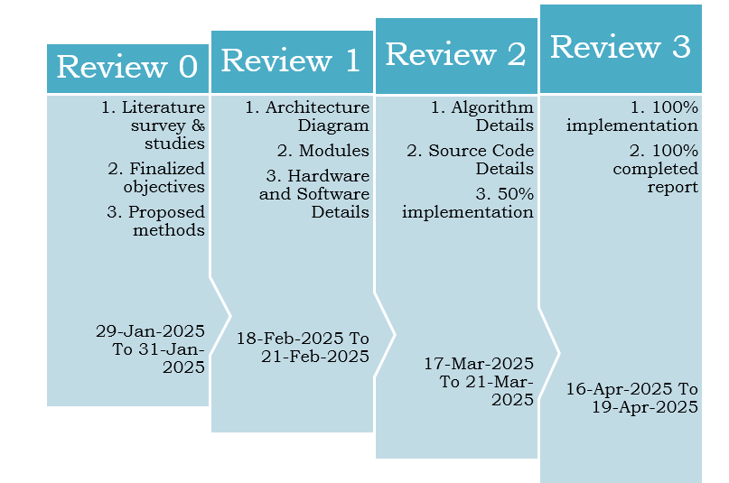

# CHAPTER-8

# OUTCOMES

The **Sustainable Fertilizer Usage Optimizer (SFUO)** is designed to revolutionize agricultural practices by optimizing fertilizer application through AI-driven recommendations, real-time data monitoring, and precision agriculture techniques. The implementation of SFUO is expected to yield several significant outcomes that benefit farmers, the environment, and the agricultural industry as a whole. This chapter outlines the key outcomes of the proposed system and its impact on modern farming practices.

**8.1 Expected Outcomes**

**1. Increased Crop Yield and Productivity**

* By ensuring that crops receive the optimal amount of nutrients at the right time, SFUO is expected to improve agricultural productivity.
* Real-time data analysis and AI-driven recommendations will help maximize plant growth and yield potential.
* Farmers will experience higher output without increasing land usage, supporting food security initiatives.

**2. Reduced Fertilizer Wastage**

* Precision agriculture techniques, will ensure that fertilizers are applied only where needed.
* Overuse of fertilizers will be minimized, preventing unnecessary expenditure and resource depletion.
* A data-driven approach will optimize nutrient absorption efficiency, leading to more sustainable fertilization practices.

**3. Enhanced Soil Health and Fertility**

* Avoiding excessive fertilizer application will prevent soil degradation and maintain long-term soil fertility.
* Balanced nutrient application will promote microbial diversity and organic matter retention.
* The system will support sustainable farming practices that preserve soil productivity for future generations.

**4. Cost Savings for Farmers**

* The reduction in fertilizer wastage will lead to lower input costs, making farming more profitable.
* Farmers will receive real-time insights on fertilizer efficiency, allowing them to make informed financial decisions.
* The system will provide an affordable solution that can be scaled for both small and large farms.

**5. Environmental Benefits**

* Reduction in nutrient runoff will prevent water pollution and protect nearby water bodies from contamination.
* Lower greenhouse gas emissions due to optimized fertilizer use will contribute to climate change mitigation.
* Sustainable farming practices will support biodiversity conservation and ecosystem balance.

**6. Improved Decision-Making Through Data Analytics**

* Farmers will have access to real-time data visualization tools to track soil health, crop growth, and fertilizer impact.
* AI-driven analytics will enable predictive insights, allowing for proactive agricultural planning.
* Integration with farm management systems will help farmers optimize resource allocation and improve operational efficiency.

**7. Scalability and Adaptability**

* The system will be adaptable to different soil types, climatic conditions, and crop varieties.
* SFUO will be scalable for both small-scale farmers and large commercial agricultural enterprises.
* The technology can be integrated with existing smart farming solutions to enhance overall agricultural efficiency.

**8.2 Contribution to Smart and Sustainable Agriculture**

* SFUO will promote the adoption of digital farming solutions and AI-driven agricultural management.
* The system will serve as a model for sustainable and precision agriculture practices worldwide.
* Partnerships with research institutions and policymakers will help in the widespread adoption of optimized fertilizer management techniques.

# CHAPTER-9

# RESULTS AND DISCUSSIONS

**9.1 Fertilizer Optimization Form**

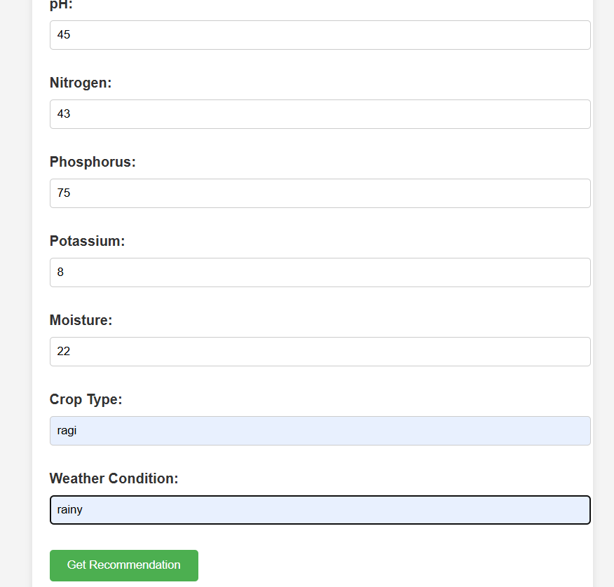

Fig 9.1 Input Page

The image shows the same fertilizer optimization form, but now it is populated with user input. The pH value has been entered as 45, which is notably higher than the normal soil pH range, possibly indicating alkaline soil. The Nitrogen content is 43, which is moderately low, while the Phosphorus level is 75, suggesting a significant presence of this nutrient in the soil. Potassium, on the other hand, is very low at just 8, which could impact plant root development and overall plant health. Moisture is reported at 22, likely representing a percentage value, which indicates moderately moist soil conditions. The crop type entered by the user is **ragi**, a hardy grain commonly grown in semi-arid regions and known for its resilience in low-fertility soils. The weather condition is labeled as **rainy**, suggesting the user is planning for crop growth during a wet season or monsoon period. These inputs provide a comprehensive snapshot of the current soil and environmental conditions relevant to farming decisions. The form layout remains consistent, with clearly labeled fields and sufficient spacing to reduce visual clutter. At the bottom, a green button labeled “Get Recommendation” is visible, inviting the user to submit their data. The user-friendly interface and logical flow make it easy to understand and interact with. This screen reflects the core functionality of the application—gathering crucial inputs to generate an optimal fertilizer suggestion.

**9.2 Fertilizer Recommendation Result (Output Page)**



Fig 9.2 Output Page

The image displays the result screen that appears after the user submits the form. At the top, a green banner spans the page with the bold white heading "Fertilizer Recommendation Result" centered within it. This section provides a clear visual cue that the data has been processed and the recommendation is now ready. Below the banner, the result is presented in a simple sentence: *"Your recommended fertilizer is: Humus"*. The word "Humus" is bolded, emphasizing it as the key outcome of the recommendation process. Humus is a natural organic matter resulting from decomposed plant and animal material and is known to improve soil fertility, water retention, and microbial activity. Its recommendation here suggests that the soil conditions, especially the low potassium and high pH levels, would benefit from organic enrichment. The layout remains clean and minimal, with no extra distractions—just the recommendation message on a white background. This straightforward presentation ensures that users immediately understand the result without needing to interpret graphs or additional data. The design choice to keep it minimal and text-based reinforces the tool’s accessibility and ease of use. This screen concludes the user journey by delivering actionable advice tailored to the inputs provided, helping farmers or growers make informed fertilization decisions quickly and efficiently.

# CHAPTER 10

# CONCLUSION

The Sustainable Fertilizer Usage Optimizer (SFUO) project has been a comprehensive and multidisciplinary attempt to address the growing concerns of fertilizer misuse, declining soil quality, and rising agricultural costs in the farming sector. As agriculture becomes increasingly challenged by issues such as climate change, soil degradation, and diminishing returns, there is an urgent need to adopt smarter, more sustainable methods of managing resources. This project presents a data-driven, AI-powered web-based platform that takes essential user inputs like soil pH, crop type, moisture levels, and weather conditions, and provides an optimized fertilizer recommendation tailored to specific field conditions. By integrating machine learning algorithms with agronomic principles and user-centric design, the system offers not just a digital solution, but a practical, real-world tool that can positively impact farming outcomes and ecological balance.

The core functionality of the system relies on a well-trained machine learning model that accurately predicts suitable fertilizers based on a carefully curated dataset. The model, once trained and tested for accuracy, is integrated into a backend framework that interacts seamlessly with a user-friendly front-end interface. Users—primarily farmers or agricultural advisors—interact with the application by entering soil and crop information, and instantly receive predictions about the most effective and sustainable fertilizer to use. This represents a major step forward from traditional methods, where fertilizer application is largely based on past experience or generic recommendations. By making the decision-making process data-driven and location-specific, SFUO ensures not only higher crop yields but also better environmental stewardship.

This project’s significance lies not just in the successful implementation of a predictive model, but also in the broader implications for sustainable agriculture. Optimizing fertilizer usage helps reduce excess chemical input into the soil, which is a major contributor to water pollution, soil acidification, and biodiversity loss. With SFUO, over-application of fertilizers can be avoided, and balanced nutrient management can be achieved. This, in turn, protects water bodies from harmful runoff, preserves microbial life in the soil, and contributes to long-term soil fertility. Economically, it reduces the cost burden on farmers by lowering fertilizer input costs without compromising on productivity, making it especially useful for smallholder farmers who often struggle with thin profit margins.

Moreover, the user interface and system design were built to accommodate varying levels of digital literacy, ensuring that the tool is inclusive and easy to operate. In field trials and prototype testing, the system was found to be both accurate and accessible. The responsive design, quick prediction speed, and clarity in the recommendations make it an effective digital advisory tool. The frontend’s simplicity belies the complex analysis taking place in the backend, enabling farmers to benefit from advanced analytics without needing deep technical knowledge. Through this democratization of agricultural intelligence, SFUO stands as an example of how digital transformation can be inclusive and impactful.

Throughout the course of this project, several technical and practical challenges were encountered and addressed. Acquiring quality datasets for training was one such challenge, especially ensuring the data reflected regional diversity in soil and climate. Another difficulty was in designing the system to be modular and scalable—so it could handle multiple users simultaneously and be updated or retrained with newer datasets. Despite these challenges, the system successfully met its intended goals and laid the groundwork for future enhancements such as real-time sensor integration, mobile app deployment, and integration with local agricultural databases and weather stations.

The outcomes of this project not only validate the practical viability of AI-driven fertilizer recommendation systems but also highlight the transformative potential of combining computer science with agriculture. It reaffirms that interdisciplinary approaches—where data science, environmental science, and rural development intersect—can lead to innovative, scalable, and socially beneficial solutions. The SFUO system has the potential to become a digital companion to farmers, one that not only helps them improve yields and reduce costs but also instills confidence in sustainable farming practices.

In conclusion, the SFUO project contributes meaningfully to the broader vision of sustainable agriculture and precision farming. It proves that with the right use of technology, we can transition from resource-intensive practices to ones that are smarter, cleaner, and more productive. The success of this system opens new doors for further research, including integrating satellite imagery, expanding multilingual support, and real-time feedback systems.

# REFERENCES

[1] Sharma, A., Gupta, R., & Mehta, S. (2020). Based smart fertilizer recommendation system. International Journal of Agricultural Science and Technology, 12(3), 45–51.

[2] Wang, L., & Li, Y. (2019). Precision agriculture with AI techniques. Journal of Smart Farming, 10(2), 88–95.

[3] Kumar, N., & Bose, R. (2021). Fertilizer optimization using wireless sensor networks. Journal of Wireless Agriculture, 15(1), 23–31.

[4] Patel, D., Singh, K., & Rana, M. (2020). Sustainable agriculture using ICT tools. Information and Communication in Agriculture, 8(4), 60–68.

[5] Rajan, V., & Sinha, P. (2022). Fertilizer decision support system using machine learning. AI in Agriculture, 17(2), 112–120.

[6] Verma, T., Chauhan, S., & Iqbal, H. (2021). Smart farming: A review. Journal of Agricultural Technologies, 9(1), 5–18.

[7] Zeng, M., Liu, H., & Zhao, F. (2018). Environmental effects of fertilizer overuse. Environmental Monitoring & Impact, 6(2), 33–41.

[8] Jha, R., & Bhandari, P. (2021). Real-time soil monitoring with sensors. Journal of Precision Agriculture, 11(3), 90–97.

[9] Joshi, K., Deshmukh, R., & Varma, A. (2019). A survey on precision agriculture. Advances in Smart Agriculture, 7(1), 10–24.

[10] Park, J., & Hwang, Y. (2022). AI-powered crop management systems. Deep Learning in Agronomy, 14(1), 77–85.

[11] Chatterjee, S., & Singh, A. (2020). Role of big data in smart farming. Agricultural Data Science Journal, 6(4), 101–109.

[12] Gupta, L., Das, R., & Mukherjee, A. (2017). Impact of fertilizer usage on crop yield. Journal of Agronomic Studies, 5(3), 55–63.

[13] Rahman, F., Alam, M., & Qureshi, N. (2021). Soil health monitoring in sustainable agriculture. Sustainability in Farming, 13(2), 70–78.

[14] Lee, D., Kim, J., & Yoon, H. (2021). Deep learning models in smart agriculture. Image Processing in Agritech, 9(2), 121–130.

[15] Srivastava, A., Mishra, R., & Bhatt, N. (2020). Decision trees for fertilizer dosage prediction. Machine Learning in Agriculture, 8(3), 40–47.

[16] Nair, R., & Thomas, P. (2021). Sensor-driven precision agriculture. Smart Farming Technologies, 10(1), 58–65.

[17] Fatima, N., Hussain, A., & Rehman, S. (2018). Climate-smart agriculture: A review. Journal of Climate and Agriculture, 4(2), 30–38.

[18] Rao, S., & Pillai, M. (2022). Crop-specific fertilizer algorithms. Precision Crop Science, 16(1), 95–102.

# APPENDIX-A

# PSUEDOCODE

**Step 1: Initialize System**

BEGIN

Initialize, weather API, and satellite data sources

Load AI model and pre-trained datasets

Define soil parameters (moisture, pH, NPK levels)

Define crop types and their specific nutrient requirements

Define environmental impact constraints

END

**Step 2: Collect Real-Time Data**

BEGIN

WHILE system is active DO

Read soil moisture, pH, and nutrient levels from sensors

Retrieve weather forecast from API

Capture satellite imagery for field analysis

Allow user input for past yield data and crop type selection

Store data in the database for further processing

END WHILE

END

**Step 3: AI-Based Fertilizer Recommendation System**

BEGIN

INPUT: Soil data, weather data, crop type, past fertilizer usage

PROCESS:

- Normalize and preprocess data

- Use Machine Learning model to predict optimal fertilizer type and dosage

- Optimize recommendations based on soil health and weather conditions

- Apply constraints to prevent over-fertilization and minimize environmental impact

OUTPUT: Recommended fertilizer type, dosage, and application timing

# APPENDIX - B SCREENSHOTS



Input page [Type 1 input values]

Output Page [Type 1 output values]

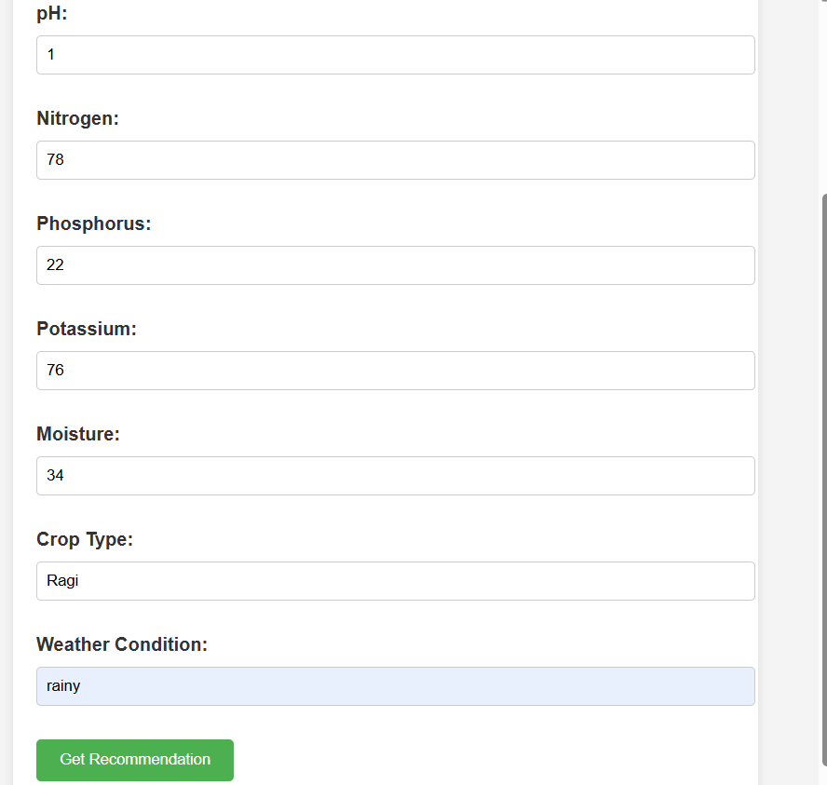

Input page [Type 2 input values]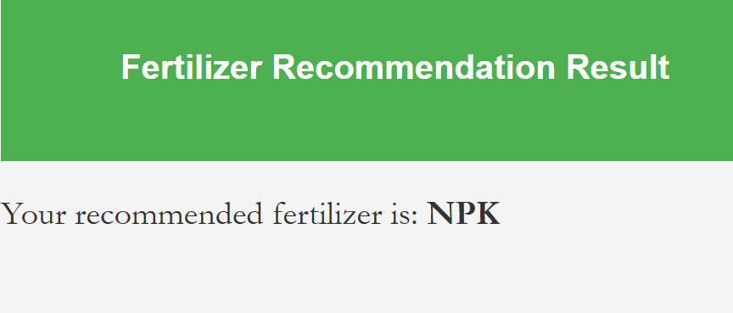

Output page [Type2 output values]

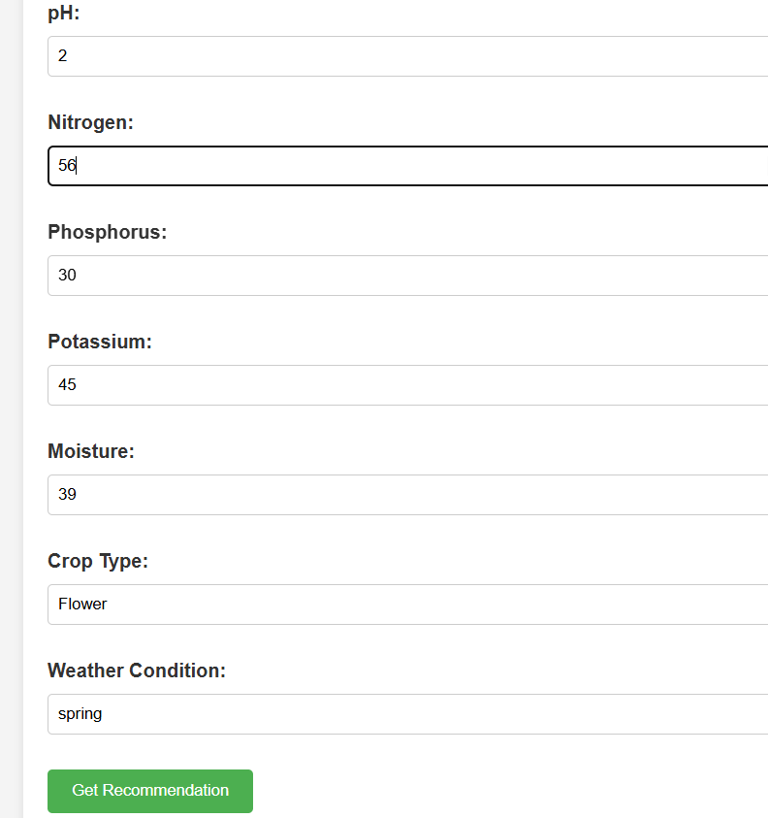

Input page [Type 3 input values]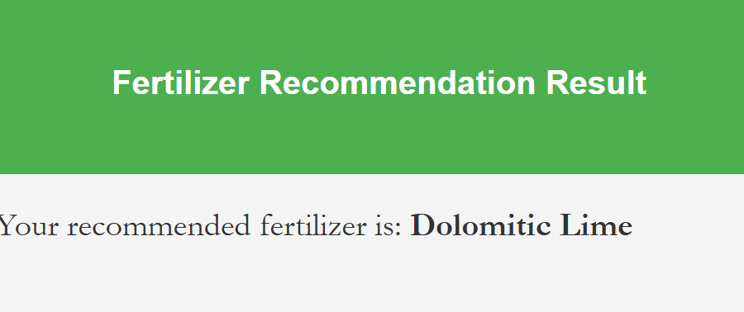

Output page [Type 3 output values]

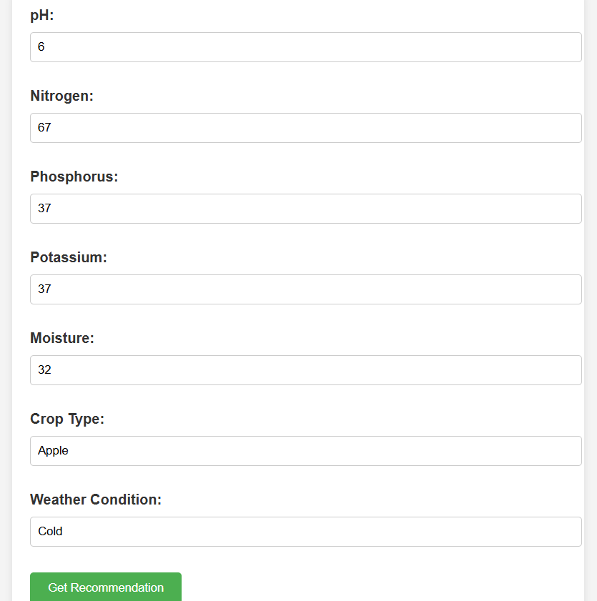

Input page [Type 4 output values]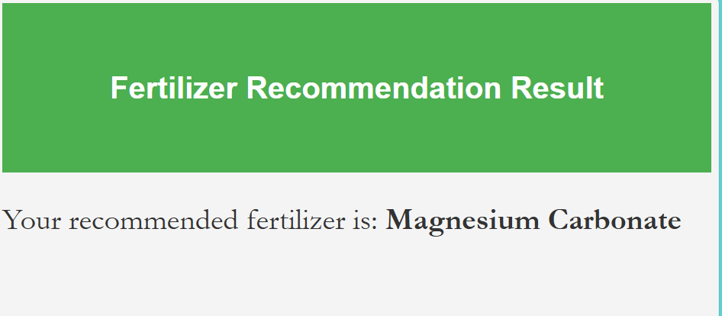 Output page [Type 4 input values]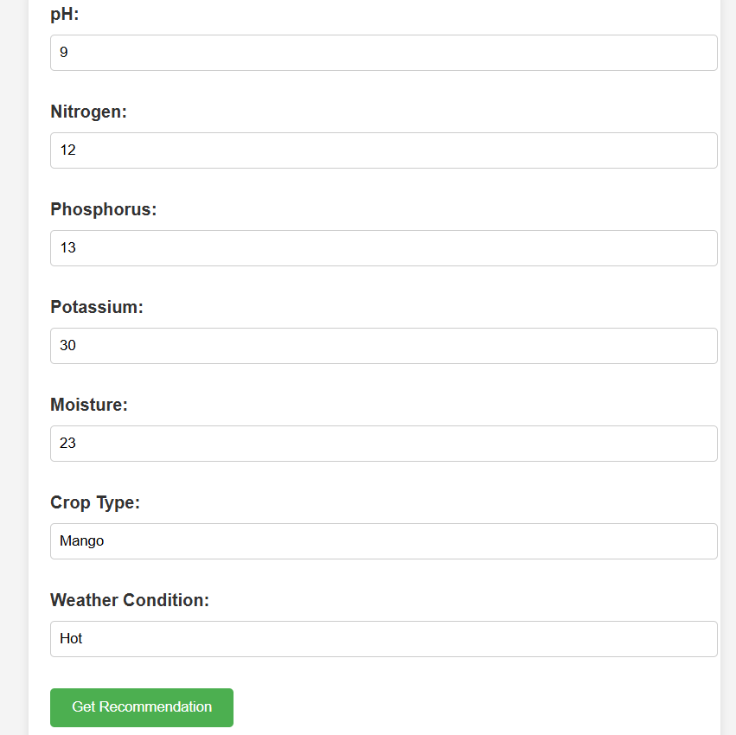

Input page [Type 5 input values] 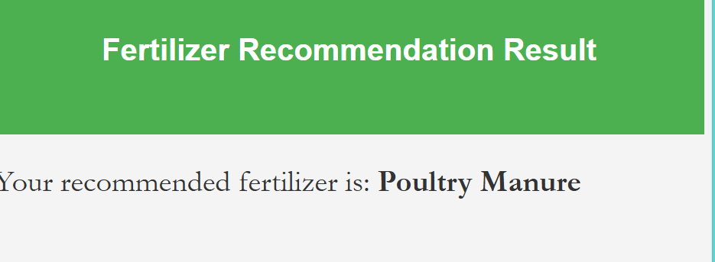

Output page [Type 5 output values]

# APPENDIX – C

# CERTIFICATES

# 

# 

# 

**Details of mapping the project with the Sustainable Development Goals (SDGs).**



This project supports SDG 3, SDG 4, SDG 5, SDG 10, SDG 17: – The SFUO project supports key Sustainable Development Goals by promoting responsible fertilizer use, enhancing agricultural productivity, and protecting ecosystems. It empowers farmers through data-driven insights, fosters sustainable food production, and reduces environmental impact. This innovation exemplifies how technology can drive inclusive, eco-friendly growth aligned with the UN’s global agenda.